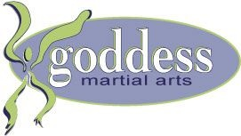
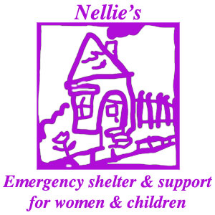
Nellie’s Presents Goddess Martial Arts

Nellie’s would like to invite you to the Women Experiencing Abuse & Violence (WEAV) Program’s first installation of Goddess Martial Arts
Women of all ages and abilities are invited to experience easy to learn/apply, trauma-informed Violence Prevention strategies and skills, including:

Safety Awareness
Effective Communication Skills
Verbal Assertiveness
Non-Aggressive Conflict Resolution
De-escalation Techniques
Basic Physical Defense Strategies

When:
Session 1 Thursday November 25th 2021 11:30am to 1:30pm
Session 2 Thursday December 2nd 2021 11:30am to 1:30pm
Session 3 Monday December 6th 2021 11:30am to 1:30pm
Session 4 Monday December 13th 2021 11:30am to 1:30pm

Where: 765 Queen St E, Toronto, ON M4M 1H3
(Intersection at Queen St E and Broadview )

Dress Comfortably!
Lunch & TTC Tokens will be provided for all participants

